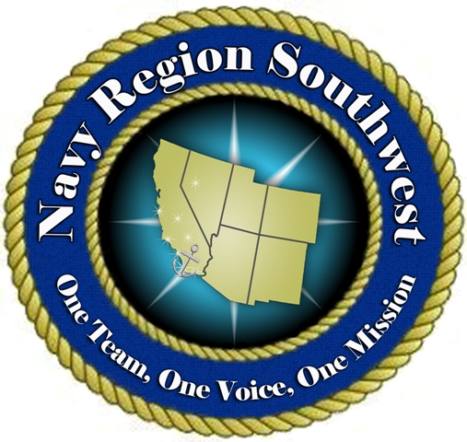2009 FREEDOM FESTIVAL 4TH OF JULY CAR SHOW 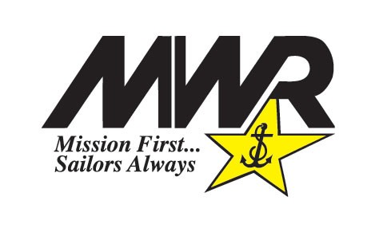
Presented by US Navy Morale, Welfare & Recreation (MWR) and
U.S.A. FEDERAL CREDIT UNION
July 4, 2009 – 4 pm Until 7 pm – NAVAL MINE AND FLEET ANTI-SUBMARINE WARFARE Center, PT. LOMA

Name of Driver: |  |  | Drivers License Number:
Daytime Phone Number & Fax Number:: |  |  | E-Mail Address:
Street Address: |  | City & State & Zip Code: |  | Zip Code:
Guest’s Name: |  |  | Guest’s Drivers License Number:
Vehicle Year: | Vehicle License: |  | Vehicle Model: |  | Vehicle Color:
Additional Vehicle Information/History/Special Needs:

In consideration for my participation in the 2009 Freedom Festival event on July 4, 2009 on board Naval Mine and Fleet Anti-Submarine Warfare Center, Point Loma, I, _______________________________, agree to indemnify and hold harmless the U.S. Government and/or its officers, agents, employees, or volunteers acting officially or otherwise, from any and all claims, demands, actions, causes of action, or suits of any nature or kind whatsoever for any loss of or damage to my property, or injury to my person (including death), which may occur from any cause whatsoever as a result of my participation in said event.

I understand and acknowledge that in order to enter said military installation I must possess a valid driver's license and/or government-issued picture I.D. I further acknowledge and understand that no animals, weapons of any kind, fireworks/explosives, alcohol, and/or illicit drugs are allowed on board the installation and that I may be subject to search.

Applicant’s Signature: Date:

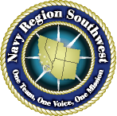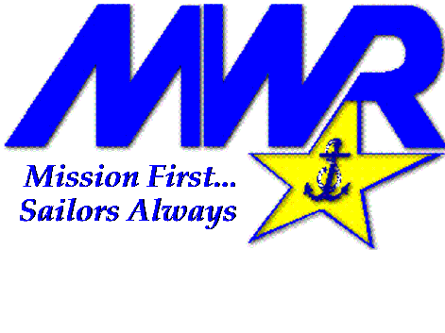

Return completed form by June 1st to
Irene J. Wells, Regional Sponsorship Coordinator
Phone: (619) 556-7464 FAX (619) 556-2333
Irene.wells@navy.mil

